Fundamentals
Don't underestimate the basics! Most learners struggle to improve for years because they lack these fundamentals.
Overview and recommendations
Key dimensions | Retrieval, deep processing, mindset
Recommended pace | Most learners see best results with 2 to 3 hours of theory across 1 to 2 weeks, interspersed with practice, as recommended below.
Recommended practice | Most learners see best results with 2 weeks of practice before moving to the next stage. You will continue to use these methods for the entire program, and you will have continuous opportunities to practise these skills in the following stages.
Progression tips | Complete each lesson in one go, then complete the respective focus tasks before moving to the next lesson. This will prevent overwhelm. Total mastery of the first lesson (Spacing, interleaving, and retrieval) is unrealistic before moving on. However, you should gain some experience with the techniques as instructed.
How this stage helps you
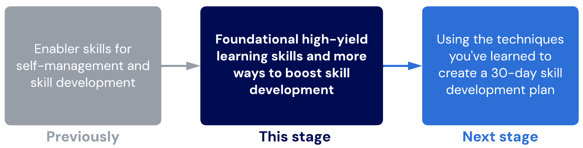
Lessons
1.Spacing, interleaving and retrieval
In this lesson, we teach you about SIR. This is a core learning technique. After this lesson, SIR will remain in your learning system throughout the entire program.
Sub-lessons
- Spacing tips
- Interleaving tips
- Retrieval tips
2.The problem with studying
What if we told you that the way most people study is flawed? In this lesson, we'll uncover common beliefs you probably have about learning that can hold you back for life.

3. Marginal gains
Developing complex skills (like learning) can be... well, complex! In this lesson, we'll introduce the concept of marginal gains and how you can use it to ensure you eventually become a super learner.
Sub-lessons
- Unpacking marginal gains
- Tracking marginal gains
- Marginal gains for studying

1.Spacing, interleaving and retrieval
Excuse me, SIR
Spaced, interleaved retrieval is one of the core foundational techniques of any learning system. Even as we teach you more learning techniques later in the program, SIR will remain.
Important notes about training SIR
- SIR is not one technique - it is a method. The difficulty of using SIR depends on the difficulty of the interleaved retrieval techniques you use.
- Retrieval techniques are generally easier to master than encoding techniques. You can expect to master each technique with only 3 to 5 hours of experience.
- The consequence of not using SIR is very high. This is explained further below.
Spaced retrieval is an easy strategy to implement straightaway, so if you aren’t doing it already, you should start now. If you already use spaced retrieval, improve your interleaving with our guidelines.
Encoding vs retrieval
Systems that rely on spaced retrieval lead to repetition and time wasting. Spaced retrieval alone is insufficient to give you a competitive advantage or to produce your desired results reliably.
However, retrieval practice is still necessary for a complete study system.
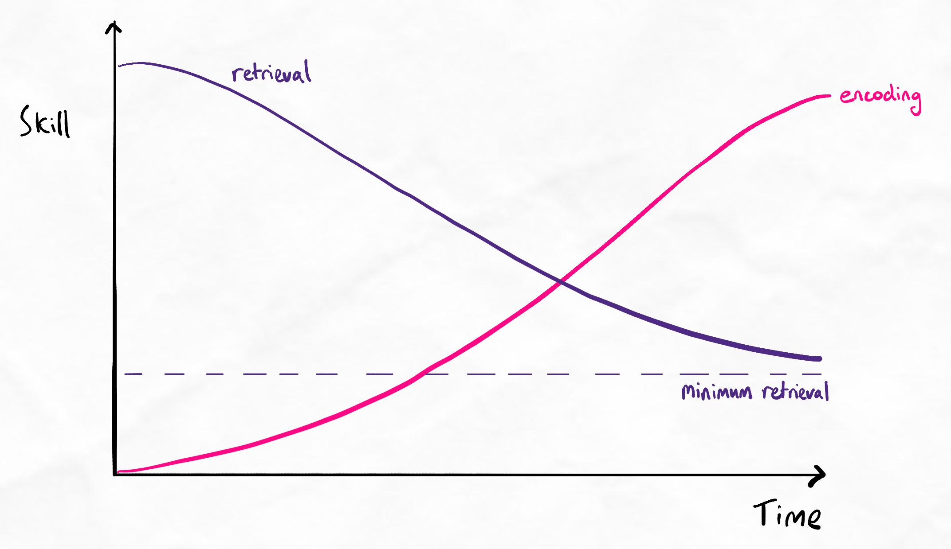Graph showing relationship between encoding and retrieval
Notice that as the encoding skill increases, retrieval requirements never become zero. We always need some level of retrieval because our brain is never leak-proof (i.e. there is always some knowledge decay).
Read our article on encoding vs. retrieval here for a more detailed explanation.
Two sides of the learning coin
You cannot be efficient and accurate without both encoding and retrieval. Outside of inadequate encoding, "retrieval failure" is a common cause of knowledge decay of previously encoded information.
When information is encoded to a higher quality, we need less retrieval.
Table of contents
Sublesson
- Spacing tips
- Interleaving tips
- Retrieval tips
- Recommended tasks
- Quiz
SIR checkpoint
- Spacing tips
How often should I space my retrieval sessions?
The purpose of spacing is to practice your retrieval and reinforce information in your memory. In general, you should wait until you are just starting to forget the material.
- If your spacing is too frequent, this will create unnecessary repetition and work as you're testing yourself too early in the forgetting curve.
- If your spacing is too infrequent, this will cause you to waste time during each revision as you've forgotten too much.
Note about language
Our usage of the term “revision” may be confusing for members in North America. Revision refers to the act of looking over material that has already been studied to consolidate and review.
Spacing interval guidelines
- Learn something for the first time
- Review: later the same day
- Next review: 2 or 3 days later
- Next review: 5 to 10 days later
- Next review: 10 to 20 days later
- Next review: 1 to 2 months later
As the interval between retrieval sessions gradually increases, this is an example of expanding-gap spaced retrieval. Research is inconclusive on the benefit of expanding-gap spaced retrieval compared to fixed interval spacing. However, we still recommend expanding-gap spaced retrieval because it makes your workload significantly more manageable.
Our recommended retrieval schedule
In practice, we can use this simple schedule:
- Revise on the same day you learned it.
- Do a mid-week revision of everything from the previous 2 days. (You can skip this if there isn’t much to revise. For high school students, this mid-week revision is often unnecessary as the volume of information is substantially lower than at university.)
- Do an end-of-week revision for the entire week’s content.
- Do an end-of-month revision for the entire month’s content.
- Revise the entire test or exam’s content in the 1 or 2 weeks before the assessment.
More guidance on spacing
Read our learning resource article here for more information on how to time your spacing intervals.
🤯 Before your brain explodes...
The tips in these sublessons are designed to be a guide to return to as you continue to practice. You do not need to remember all of the tips immediately!
When you create retrieval plans in your schedule and practise, refer to these lessons for guidance. It will be much easier than trying to remember everything before you've even started applying it!
- Interleaving tips
To use interleaving, review information from multiple angles and perspectives. Research strongly shows that using more interleaving produces better results. It also protects you from curveball exam questions because you are used to seeing the information in multiple ways.
SIR is here to stay
Remember, you will rely less on retrieval as you get better at encoding.
However, every learning system should always have at least some level of interleaved retrieval practice, even if your encoding is perfect. This is because the human brain always prunes information that isn't being used.
What is 'expertise'?
The goal of every learner is to develop expertise. Expertise means you can answer any question and solve any problem. However, an expert's "knowledge structure" or "knowledge network" (i.e. how they have organised information in their brain) is different to that of a novice.
If we don't know how to create the knowledge structure of an expert, it's very hard to develop expertise. Whenever we do any learning (encoding or retrieval), we should always try to build true expertise. This improves memory and fluency.
To understand what "expertise" looks and feels like, we recommend reading our article here on higher-order vs. lower-order learning to understand how we can think about mastery and expertise.
Terminology
From here on, we will continue to use terminology related to higher-order learning and developing expertise, as explained in the article.
Understanding different interleaving techniques
There are a near-endless number of ways to challenge your knowledge. The below is just a small list of examples:
- Teach an imaginary student
- Draw a mindmap
- Draw an image instead of using words (to find a visual way of expressing information)
- Answer practice questions
- Create your own challenging test questions
- Create a test question that puts what you’ve learned into a real-world context
- Take a difficult question you found in a practice test and modify it so that it involves different variables or adds an extra step
- Form a study group and quiz each other (for some subjects, you can even debate the topic, with one side trying to prove that the other person is missing a point or understanding it incorrectly)
Which interleaving technique should I use?
There is no single interleaving technique that is best for every subject and context. Finding the right combination of interleaving techniques takes some time and experience.
Key principles for interleaving
- Use different interleaving techniques for different retrieval sessions. Using the same method to repeatedly challenge your knowledge in the same way has limited benefits.
- Cover your full spectrum of orders of learning and procedural needs across your combination of interleaving techniques.
- Start with higher-order interleaving techniques in the earlier retrieval sessions to find big-picture gaps and weaknesses. These are more harmful when missed than gaps in small details.
- Lower-order interleaving techniques can either be used in parallel whenever you have gaps in time, or crammed in the later retrieval sessions.
Deciding on the best set of interleaving techniques
- Identify what order of knowledge retrieval you need. How much lower-order vs. higher-order retrieval do you need?
- Identify how procedural your retrieval needs are. For example, maths and coding are very procedural, while biology is mostly conceptual.
- Experiment with using an interleaving technique that covers your order of learning and procedural needs.
Key resource
We’ve compiled a comprehensive resource to help you use different interleaving techniques, including examples for different disciplines and subjects. We strongly recommend checking out the table and integrating some of them into your schedule.
This resource will be especially useful if you are interested in learning languages, maths, and coding more efficiently.
Check out the interleaving table here. You can also find this unlocked in your Toolkit on the left side menu or in the Learning Support page.
We also recommend checking out Live Clinic 39, which goes deeper into interleaving for procedural skills like maths and coding.
- What is retrieval?

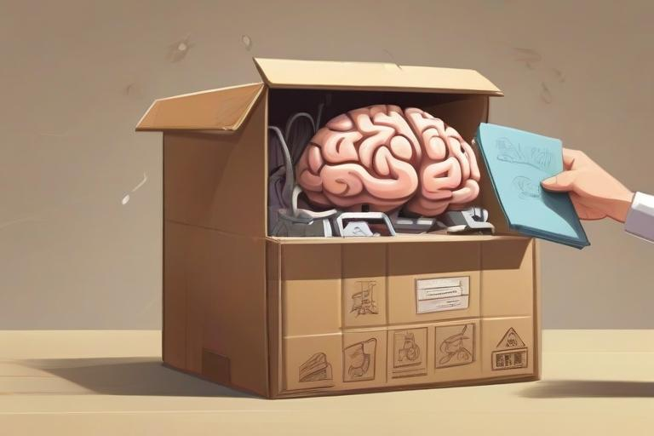
Retrieval means taking information from your long-term memory and bringing it into your working memory to recall, solve problems and answer questions.
Key principle
Retrieval practice is a well-evidenced and important part of learning. No learning system is complete without adequate retrieval practice.
Types of retrieval practice
There are many different ways to do retrieval practice. We recommend utilising as many of these as possible. Time invested in these methods pays itself off in improvements to your retention.
Dedicated retrieval sessions
In these sessions, you are scheduling time for retrieval practice. Refer to the interleaving table for more advice on the types of methods you can use. Many students have a dedicated retrieval practice day every weekend.
Tips:
- Don’t look at your notes within at least 12 hours of the session. Checking notes too recently can simply cue the information back into your working memory without you actively needing to retrieve it. This is unrealistic practice for exam situations.
- Always generate an answer, even if you are unsure. Getting the wrong answer helps you remember the right answer when you correct yourself later. Commit to answering every question or test, even if it's just a guess.
- Practice retrieving information fully as if you were being assessed. For example, when teaching, teach out loud and articulate properly. When writing answers, write the best answer you can. When creating questions, write the most specific and high-quality questions you can. In an exam situation, our retrieval needs to be highly accurate and at a high standard. Practising this high standard of retrieval during revision helps identify subtle weaknesses we might not realise are there until we are put to the test.
Retrieval while studying and during class (micro-retrieval)
Whenever you study, look for opportunities to do some “micro-retrieval”.
For example, before writing notes in class, always give yourself time to think and process what was said. It’s better to write about a group of concepts after you’ve thought about it rather than write it down first and then think about it. Not only does this increase “intrinsic cognitive load,” which improves retention, but it also makes you more strategic and deliberate with note-taking.
This is also called “elaborative rehearsal” or "maintenance rehearsal" in some learning models (depending on the level of processing involved).
Tips:
- Never write any notes before you have processed the information and made sense of it mentally first.
- When you do write notes, always try to write from memory first before referring back to your notes.
- Avoid writing in full sentences or paragraphs. Stick to keywords, brief statements, doodles, arrows, and lines. It is much more efficient and versatile to express information non-linearly than to describe every relationship and connection one at a time.

Retrieval during execution
Some learners will have the opportunity to retrieve their knowledge as a natural part of their work. For example, doctors or clinical medical students must retrieve their knowledge while diagnosing patients. Software developers must retrieve their programming knowledge as part of development work.
In these settings, try to identify which orders of learning and types of knowledge (declarative vs. procedural) are being tested. Use dedicated retrieval sessions to fill any deficits.
Refer to the interleaving table for more guidance around different interleaving methods and how they relate to orders of learning and types of knowledge.

What is too much retrieval practice?
In modern research, we understand that over-reliance on retrieval practice without adequate encoding can be problematic. This usually occurs when encoding is done to a low quality, resulting in high rates of knowledge decay (forgetting) and an overwhelming amount of material to learn through tedious repetition.
How to avoid over-relying on retrieval
- Continuously work on improving your encoding skills (we will teach you these methods in the next stages).
- Ensure you have multiple orders of interleaving (refer to the interleaving table in your learning resources).
- Use lower-order rote-memorisation (direct recall with spaced repetition) as a last resort for information that does not integrate into your knowledge network.
- Always try to connect new information to the big picture and think of why it is important. This helps to integrate it into your knowledge networks.

Completing these tasks
As spaced, interleaved retrieval requires a spacing interval between retrieval sessions, it can take months to master interleaving techniques.
To complete these tasks, we recommend incorporating SIR into your schedule and having at least one week's worth of practice before moving on. You can continue to practice this over time instead of waiting months to master it before moving to your next lesson.
Less than one week of practice is not advised.
Recommended tasks
Add tasks to your focus list so you can practice the skills.
Dimensions
Fundamentals
Create a one-month SIR schedule
Using the techniques and guidelines from the SIR lesson in fundamentals and the interleaving table, schedule your retrieval sessions for the next month.
Complete at least the first week before marking this task as complete. You do not need to complete the entire month before moving on.
You may create your own SIR combination or use the example combinations provided in the interleaving table.

SIR checkpoint
Before you begin this quiz
Before starting this quiz, we recommend you first review our interleaving table. Find it in your Toolkit on the left-side menu or in Learning support. It will also help to have some experience with interleaved retrieval using our recommended tasks.

Question 1.1
Michael is a first-year computer science and engineering student without experience developing and building web applications. In the first semester, his university teaches a programming language called Javascript. In the second semester, he is taught another language called PHP. Javascript and PHP are often used together to produce web apps. When used correctly, they can produce web apps that have much more diverse and complex functionality than either one alone.

What kind of approach to learning would be most beneficial for Michael to learn programming?
He should develop a big-picture theoretical understanding of the programming languages and move to primarily procedural-focused interleaving methods.
He should use declarative-focused interleaving methods with some procedural methods intermittently.
He should begin with procedural-focused methods and ignore the declarative and theoretical aspects
He should begin with a challenging project that is far beyond his current skill level and learn while attempting to complete it.
Ans: He should develop a big-picture theoretical understanding of the programming languages and move to primarily procedural-focused interleaving methods.

Learning notes
For procedurally heavy disciplines like programming, the theoretical component is usually smaller than in declarative heavy subjects (like many sciences). However, the theoretical component is still important for enhancing our ability to apply knowledge appropriately and guide our procedural practice.

After developing a rapid theoretical understanding of the programming languages' logic, purpose, functions, and relationships, Michael should move to procedurally dominant methods of interleaved retrieval.

Both procedural and declarative knowledge are necessary to develop a skill proficiently. Ignoring the theory creates a bottleneck of declarative knowledge, increasing the risk of being a technically capable programmer who is unable to design logical, efficient, and strategically aligned software solutions. Ignoring the procedural aspects creates a bottleneck in procedural knowledge, increasing the risk of being adept at high-level design but unable to code efficiently.

About excessive challenge
Learning through very high challenges can also be effective, but there is no benefit to starting at this level, instead of progressing from more basic levels of execution and working towards higher levels of challenges swiftly. On the other hand, over-challenging himself can result in slower skill acquisition due to reproductively high error rates. For example, trying to learn to juggle by starting with 7 balls.

Question 1.2
Michael is a first-year computer science and engineering student without experience developing and building web applications. In the first semester, his university teaches a programming language called Javascript. In the second semester, he is taught another language called PHP. Javascript and PHP are often used together to produce web apps. When used correctly, they can produce web apps that have much more diverse and complex functionality than either one alone.
Michael is deciding on the best way to focus his time. Choose the correct statement.
He should focus on learning both languages at the same time.
He should focus on learning the theory and practising the application of both languages at the same time.
He should aim to gain reasonable competence with each set of functions individually, the combine them with previously learned functions as he goes.

Ans: He should focus on learning both languages at the same time.
He should focus on learning the theory and practising the application of both languages at the same time.
He should aim to gain reasonable competence with each set of functions individually, the combine them with previously learned functions as he goes.

Learning notes
When learning any topic or skill, it is generally useful to learn wider before learning deeper. This is because building knowledge and skills is similar to constructing a building. Building a narrow and tall tower is much more unstable and difficult compared to a pyramid.
Similarly, depth is easier to attain when there is a strong foundation of wider, more basic principles to build on. The learnings from one domain can often assist in learning another domain.
In this scenario, Michael would benefit from learning both languages simultaneously, as we know both are related and often used together. Likewise, when learning the theory and applying the knowledge, both should be done together or alternated between frequently to maximise learning.
As his expertise grows, he should constantly consolidate what he has learned so that his network of knowledge strengthens. This is a natural way to ensure spaced retrieval of prior learnings while also challenging them at higher orders over time.

Question 2.1
Gabriella is a biology major who has recently started improving her learning skills through a state-of-the-art learning skills program. She is fascinated by improving her learning efficiency through improving her encoding. She has previously had bad experiences with becoming overwhelmed by flashcards. Although they were effective, they were too time-consuming. She also noticed that they were not as effective recently as a few years ago when she was still in high school.
Answer
Gabriella spends one month gradually improving her encoding skills. She is extremely focused and diligent on improving her encoding. However, she finds that her overall performance is not as good as she had hoped. Specifically, she makes more mistakes during exams and feels overconfident. Which of the following is the most likely reason for this?
She has learned the encoding techniques incorrectly.
She does not have enough retrieval practice.
She is a perfectionist and feels it is never good enough.
This is a normal part of improving learning skills in the short-term. Over time, her results should improve again.
Ans: She does not have enough retrieval practice.

Learning notes
Gabriella's increased error rate and overconfidence are signs of a lack of retrieval practice.
Common issue
When learning new encoding skills intensively, it's common for people to forget about how important retrieval is in a learning system, especially in the early stages when encoding is still developing.
When improving learning skills, techniques and methods should be incorporated and replaced gradually. This is to avoid sudden changes in your learning system that can cause more harm than good. It is also unlikely that these undesirable results have arisen from learning incorrect encoding techniques. This is usually because most people start with unrefined encoding methods, so most attempts to improve it tend to be positive overall.

Question 2.2
Gabriella is a biology major who has recently started improving her learning skills through a state-of-the-art learning skills program. She is fascinated by improving her learning efficiency through improving her encoding. She has previously had bad experiences with becoming overwhelmed by flashcards. Although they were effective, they were too time-consuming. She also noticed that they were not as effective recently as a few years ago when she was still in high school.
A year later, Gabriella has decided to take a maths paper at university, alongside her biology major. She notices that while her interleaved retrieval methods are excellent for biology, they do not feel helpful for maths. Choose the correct statement.
Some subjects (like maths) have more procedural knowledge requirements. These call for more procedural-focused interleaving methods.
If interleaved retrieval is not effective, it suggests that the type of retrieval method is not aligned with the subject.
Choosing appropriate and effective interleaved retrieval methods is more challenging when you have multiple subjects with different declarative vs. procedural requirements.

Ans: Some subjects (like maths) have more procedural knowledge requirements. These call for more procedural-focused interleaving methods.
If interleaved retrieval is not effective, it suggests that the type of retrieval method is not aligned with the subject.
Choosing appropriate and effective interleaved retrieval methods is more challenging when you have multiple subjects with different declarative vs. procedural requirements.

Learning notes
Interleaved retrieval should always match the balance of procedural and declarative knowledge required. It is not advisable or effective to use the same methods for every subject and discipline if their balance of procedural to declarative knowledge is different.
When retrieval practice feels less effective, it indicates that either the knowledge type of order of learning is not aligned.
While retrieval practice can be more challenging when encoding is done poorly, it does not make it less effective. The purpose of retrieval practice is to find knowledge gaps for targeted review and consolidation. When encoding is done poorly, retrieval practice is more time-consuming (as there are more knowledge gaps), but it does not make retrieval any less effective at finding these gaps.
Furthermore, interleaving methods for procedural knowledge tend to be easier and more straightforward, even though these methods are less common in formal education. The reason they tend to be more straightforward is explained in the interleaving table.
While declarative knowledge is often more compatible with flashcards, flashcards are a mostly lower-order method of retrieval, so their effectiveness is limited to helping with lower-order knowledge mastery. Although flashcards are easy to use, procedural interleaving often does not even require continuous lower-order retrieval practice because higher-order methods naturally incorporate lower-order testing. This reasoning is also explained in the interleaving table.

Question 3
Steve is a 3rd-year medical student about to sit a history-taking OSCE (Objective Structured Clinical Examination). He will be assessed on his ability to interview patients by asking questions about their condition in a logical manner to determine a diagnosis and propose a suitable treatment. Steve has been told ahead of time that the patient would have one of four possible respiratory conditions he has learned about. He is fairly confident in his knowledge about each individual condition, but is unsure about whether he can use this knowledge to conduct a patient interview and create a personalised treatment plan.
Which of the following is the best way for Steve to prepare?
Repeating a list of questions he has to ask during the patient interview from memory, for each condition. He should do this until all questions have been memorised.
Using the “simple relational teaching” method for each condition to develop robust theoretical knowledge.
Using the “challenge case (integrative)” method using cases involving multiple conditions to practise interview technique and his ability to propose a suitable treatment.
Using the “challenge case (simple)” method for each individual condition to practise interview technique and his ability to propose a suitable treatment.
Ans: Using the “challenge case (integrative)” method using cases involving multiple conditions to practise interview technique and his ability to propose a suitable treatment.

Learning notes
Steve must focus on a method of interleaving that challenges both his declarative knowledge and his procedural knowledge in conducting interviews. This is especially true as Steve already has confidence in his baseline theoretical knowledge for each condition.
Therefore, lower-order memorisation such as repeating questions, or mid-order declarative-focused methods such as simple relational teaching are unlikely to be sufficient.
While Steve could use the challenge case (simple) method, he already feels confident in his knowledge for each condition. Therefore, Steve should challenge himself at a higher level using the integrative challenge method.

Question 4
Glu has ambitions to become the world’s greatest super villain. However, to do so, he needs to ace his university physics exam that is coming in 3 weeks. One does not simply shrink the moon by failing quantum mechanics. He understands that physics is both a declarative and procedural subject. He feels confident with the basics, but he is equally unconfident with both declarative and procedural components for solving more complex problems (like shrinking the moon). He is a busy super villain but Glu is willing to put in the work.
Assuming that his only problem is that he needs to do spaced, interleaved revision, which of the following would be the ideal combination of techniques?
He should use simple relational teaching, brain dump (mindmap), use flashcards, solve textbook-provided practice questions, and redesign his mind map to look simpler. He should revise daily using a combination of these techniques.
He should make his minions dress up as him and do the exam.
He should complete practice questions (direct method), repeat chunkmaps, and use flashcards. He should revise every three days using a combination of these techniques.
He should develop his own challenge questions, do simple relational reteaching, and add additional variables to textbook-provided questions. He should revise every three days using a combination of these techniques.
Ans: He should develop his own challenge questions, do simple relational reteaching, and add additional variables to textbook-provided questions. He should revise every three days using a combination of these techniques.

Learning notes
Glu struggles with more complex applications of knowledge. This indicates he needs to work on his higher-order retrieval. Only two options cover higher-order needs sufficiently. However, one option requires Glu to revise daily, while the other has a longer spacing interval of three days. The longer spacing interval is likely to be more appropriate as it is more manageable on a busy schedule, as well as more beneficial for finding long-term memory gaps.

Question 5
Jean is trying to learn Mandarin for the first time. She tries using flashcards to memorise all the vocabulary and is able to answer her flashcards correctly most of the time. She understands how sentences must be structured and she is told that her pronunciation of words is good! Unfortunately, she still finds that she is unable to speak Mandarin coherently in real-life conversations.

What is the next best step that Jean can take to improve her speaking ability?
Think of a common scenario where she would need to speak Mandarin and practise several variations of conversations that could arise in this setting until she feels confident to navigate a real-life dialogue in this scenario
Chain dialogues and phrases together to create a simple, varied conversation starting with phrases she has already learned
Memorise a simple scripted conversation between a consumer and shopkeeper in her textbook by active recall
Create flashcards for grammar and sentence structures to supplement her flashcards for vocabulary
Ans: Chain dialogues and phrases together to create a simple, varied conversation starting with phrases she has already learned

Learning notes
Chaining dialogue is an example of retrieved execution (applied). It seems that Jean’s current level of mastery is relatively low, since she is able to recall isolated vocabulary under cued recall, but is unable to engage in uncued recall and apply her knowledge efficiently.
As the bottleneck is in application of knowledge, declarative-focused methods are not likely to be very beneficial. Jean must focus on some form of retrieved execution to build better procedural and conditional knowledge.
Chaining dialogues to create simple and varied conversations using phrases she has already learned is a good next step for Jean’s skill level. Taking this a step further into integrative or applied retrieved execution (such as attempting to gain fluency in real-life scenarios with multiple variations of conversations) is likely to be too difficult for her at this time.

Question 6
Sam graduated from university six years ago but enjoys learning from productivity and business books. She has hopes of becoming a successful entrepreneur and loves self-learning. Sam reads and listens to several books per year. She finds the concepts fascinating and she feels that she understands them easily.

How can Sam learn from these books to effectively prepare her for applying her knowledge in real life?
Continue to read many more books to improve her theoretical knowledge. Once she has enough theoretical knowledge to avoid making mistakes, apply the knowledge by starting a business. To apply as much knowledge as possible, she should try to grow this business quickly.
Create relational flashcards that summarise the main relationships between the core ideas of the books they have read and go through their flashcards each week.
Write non-linear, relational notes for each book they have read to express the key relationships between concepts and how the influence each other.
Start a simple, low-cost business where she can apply the principles she learns immediately. She can grow this business slowly or quickly, depending on what kind of principles she wants to apply.

Ans: Start a simple, low-cost business where she can apply the principles she learns immediately. She can grow this business slowly or quickly, depending on what kind of principles she wants to apply.

Learning notes
Sam must apply her knowledge to find gaps in both declarative and procedural knowledge. This should be done in a fail-fast-fail-safe approach. Starting a low-cost business that does not need to grow aggressively allows her to apply her knowledge immediately, without much risk of failure. Delaying the application of theory until she can “avoid making mistakes” is unrealistic and unhelpful as the gaps in her knowledge will remain untested.
In this scenario, declarative-focused methods will have limited benefits as the concepts are not difficult to understand. In addition, her bottleneck to applying knowledge in real life is in her low procedural and conditional knowledge, rather than declarative knowledge.

2. The problem with studying
Key points
- Study systems built around spaced retrieval (i.e. repetition) are no longer unique or sufficient.
- Using techniques that change the slope of the forgetting curve is more effective than doing more repetition.
- We tend to believe harmful myths about studying and learning due to a lack of accurate mainstream information.
- We are more confident about things we know very little about, which can cause us to reject the advice we need most.
Recognising when we are on Mt. Stupid
Internationally best-selling author Adam Grant recommends asking yourself:
“What conditions are necessary for my belief to be true?”
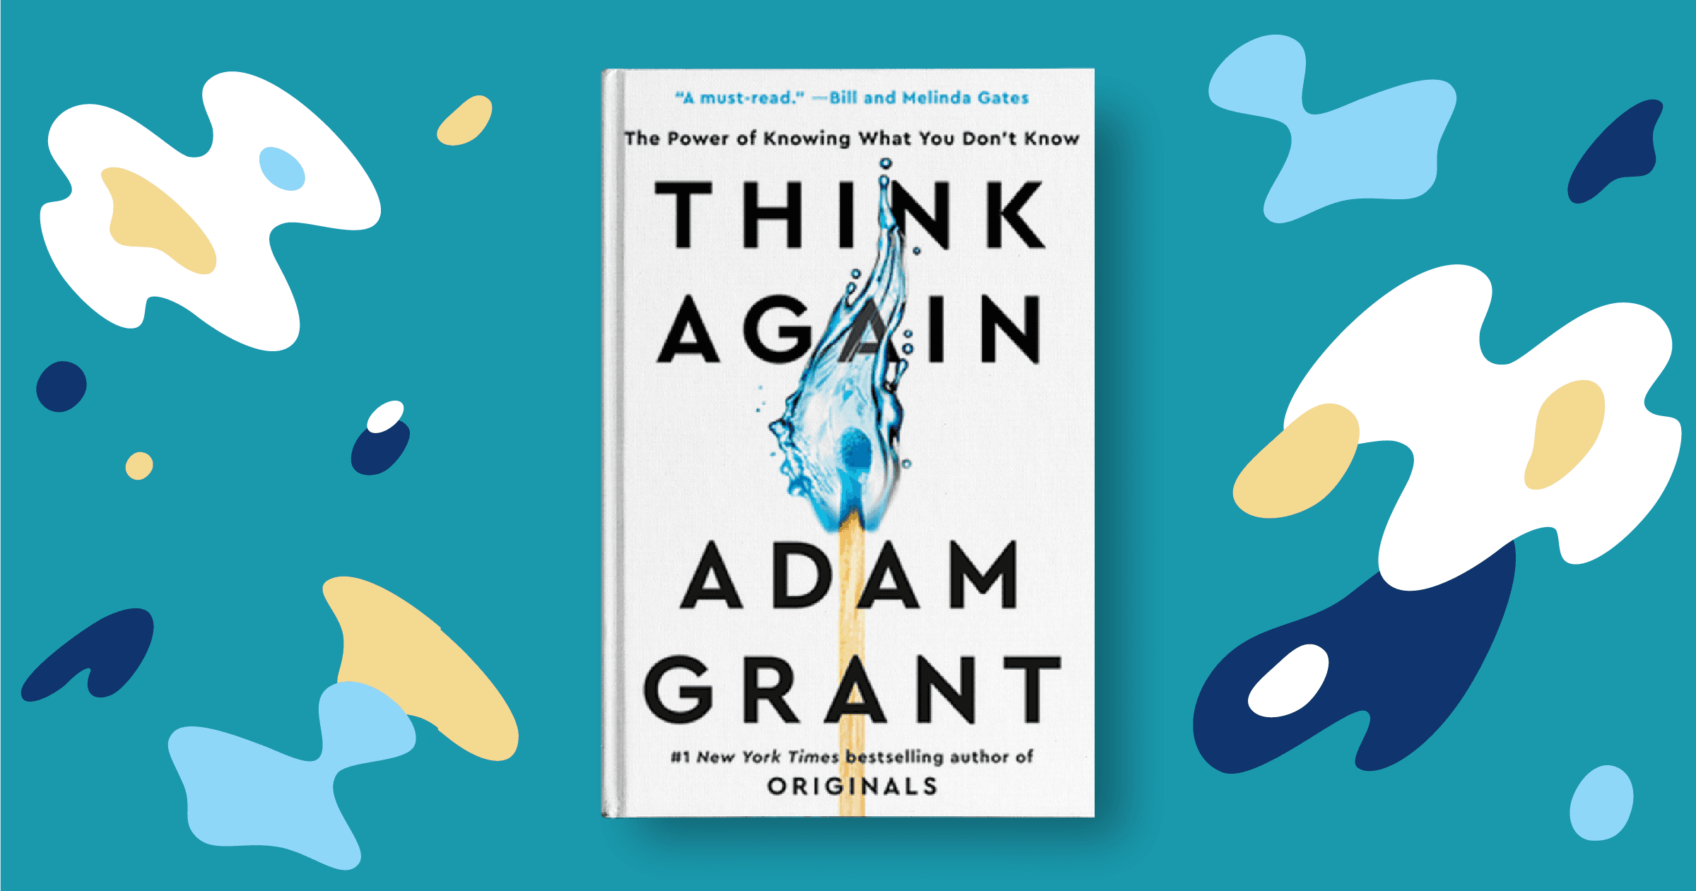Adam Grant talks about these principles in his bestselling book Think Again. Photo source: Goodreads.com
By asking yourself this, you can objectively examine the likelihood that your belief is true.
For example, if you believe your method of studying is the best, the conditions for it to be true are that:
- You know all of the alternatives,
- You know these alternatives deeply enough to assess their effectiveness accurately,
- You are aware of what “the best” means,
- You have started using “the best” method potentially without any training (and potentially from a young age), and
- “The best” method must be very common (if your approach is similar to how others study).
A faster way to assess your confidence
Another approach is to assess your confidence. This is a method Dr Justin Sung mentions often. Consider the graph below of the Dunning-Kruger effect curve.

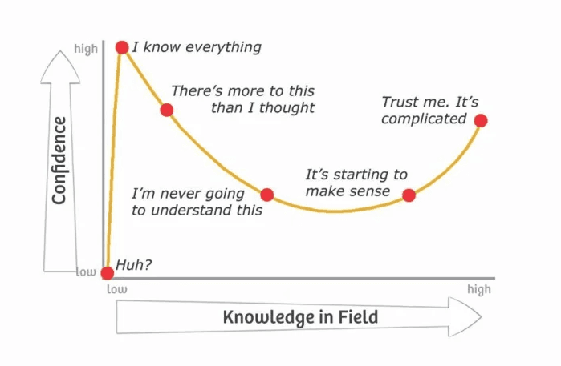The classic Dunning Kruger Effect curve. Image source: dev.to
Since there are only two points in the graph where a person’s confidence is high, you can ask yourself:
- Do you have a high level of confidence?
- Have you spent enough time learning about this to be considered a professional?
If your first answer is yes but your second answer is no, you are probably near Mt. Stupid!
Self-awareness is the key
We’re all on Mt. Stupid for something. If we can recognise that our sense of confidence may not match our actual expertise, we can be more open-minded and accept advice. This is a hallmark of a successful learner.
Learn more
You can learn more about the Dunning-Kruger effect here. There is also some controversy around the Dunning-Kruger effect in relation to the original Dunning-Kruger graph from the initial study. However, substantial additional research since the original study has supported the validity of the Dunning-Kruger effect as presented in this lesson. Further information about this controversy (as well as links to relevant references) is provided in the Briefing stage for those interested.

- Marginal gains
Key points
- Consistency is better than sudden bursts of effort
- Marginal gains are not only easier and more sustainable, they also produce a greater total effect
- Marginal gains stack and compound, which is why starting imperfectly now is better than starting perfectly later and missing out on compound gains
In our experience, it is extremely rare for learners to think about progress in marginal gains (especially among our younger high school learners). Adopting this method of thinking is a sign of intelligence and maturity, as it indicates the person:
- Appreciates that skills take time to develop
- Understands that time spent on trying to make "large strides" instead of marginal gains is often wasted and ineffective
- Recognises that the worst case scenario is not that they develop the skill slowly, but they may fail to develop it at all.
Key principle
Marginal gains create safety of success. Therefore, progressing through "large strides" and "big jumps" is unwise because it sacrifices safety for a temporary (and unlikely) boost.

Table of contents
Sublessons
- Unpacking marginal gains
- Tracking marginal gains
- Marginal gains for studying

  - Unpacking marginal gains
The concept of marginal gains is widespread since James Clear published his international bestseller, Atomic Habits.
Utilising marginal gains is a powerful tool to have in your toolkit. It is a secret weapon of some of the world’s most successful and high-performing individuals. Mastering marginal gains at a young age is a competitive advantage that few people can beat.
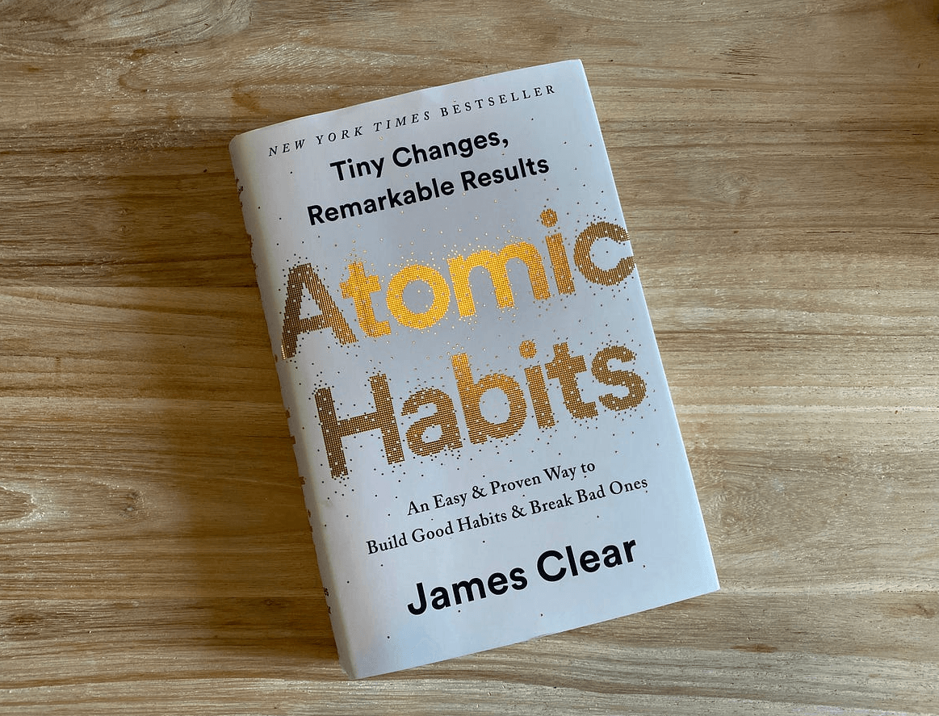Image source: https://medium.com/@aidanhornsby/notes-on-atomic-habits-c021e38eeae7
However, it's essential to recognise the different types of gains. This is a practical nuance to the concept that we rarely see discussed.
Types of "gains"
In the graph below, you can see that there are three different coloured lines. The green top line represents positive gains. This is what we want! The grey line in the middle represents fluctuating gains. The red line at the bottom represents negative gains.
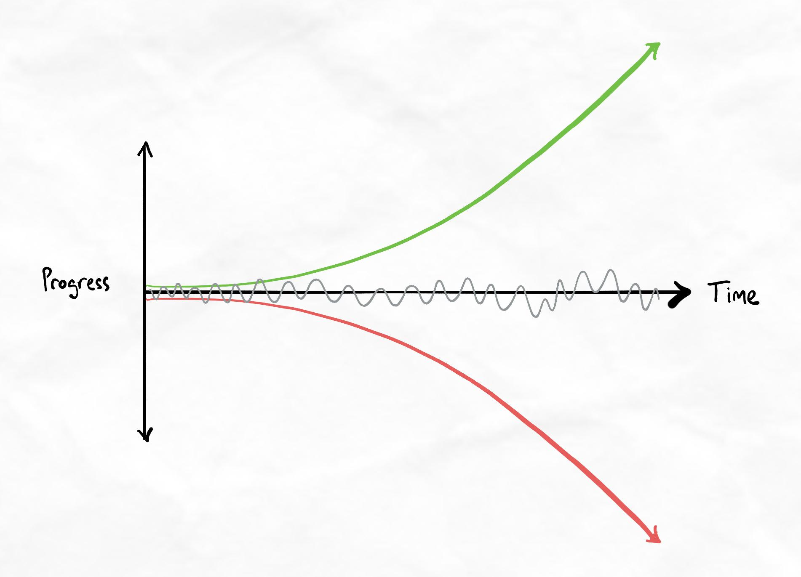There are three types of marginal gains. Positive, fluctuating, and negative.
The table below outlines the nature of these three types of gains.
Type of gain | How this gain occurs | Root problem
Positive  Desirable progress towards goals | Gains compound positively. Each 1% gain builds on the previous one. This could be building on previous knowledge, skills, and processes. | No problems!
Fluctuating  Causes a lack of progress, demotivation, and burnout. | There is 1% change, but each 1% change does not build on the previous one. As a result, the gains do not compound. Skills and processes fluctuate between getting better and worse. | This is a problem with the entire approach to progress. Occurs if you think about marginal gains inconsistently.
Negative  Causes progress away from goals. Worsens position. | Gains compound negatively. Each 1% gain builds on the previous one. However, they worsen skills, knowledge, and processes. | This is a problem with a lack of reliable information, calibration, and/or feedback on progress.
How to ensure you get positive marginal gains
Follow the guidelines below to make sure your gains take you closer to your goal.
- Think about marginal gains consistently. Train yourself to view progress through this lens by default.
- Whenever you make mistakes, feed them back in as reflections for your next cycle of experiments.
- Avoid randomly experimenting on different changes every time.
- Get feedback on your work and progress regularly.
- Ensure you are getting advice from reliable, qualified sources of expertise.
  - Tracking your marginal gains

Tracking marginal gains is about seeing progress.
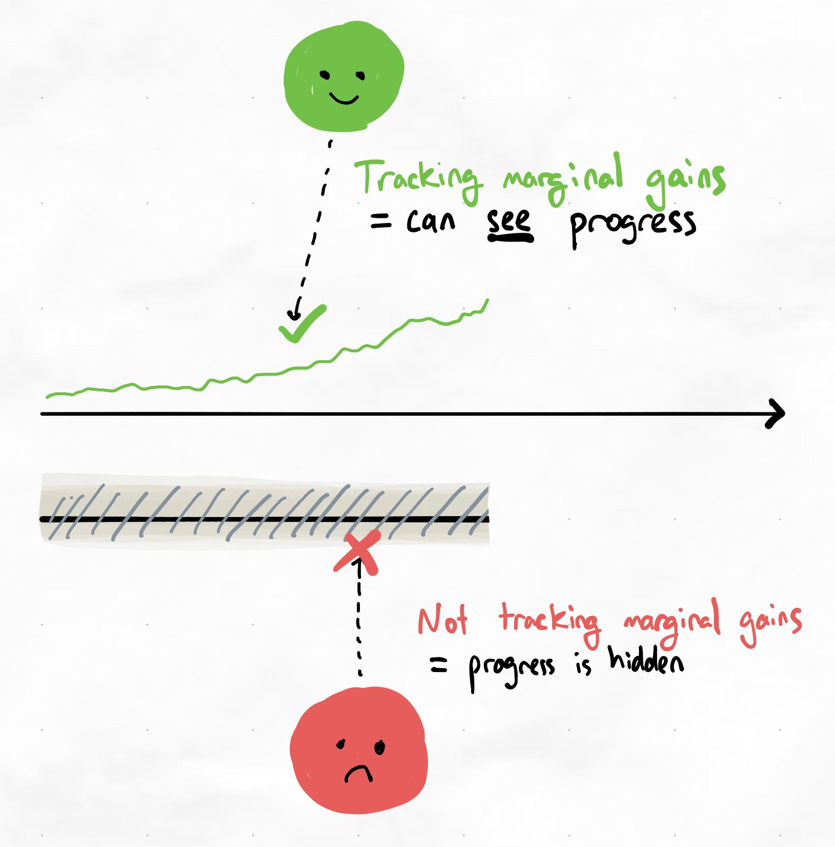
Failure to track marginal gains means a failure to see progress. This is one of the most common causes of demotivation in the early stages of skill development.
You can't trust your brain
The human brain is terrible at tracking small changes that occur gradually. Therefore, most people will have absolutely no intuitive sense of whether they are making marginal gains during the early stages. Tracking it actively is one of the only ways to visualise and "feel" the progress.
Viewing progress through marginal gains is what creates a positive motivation cycle.
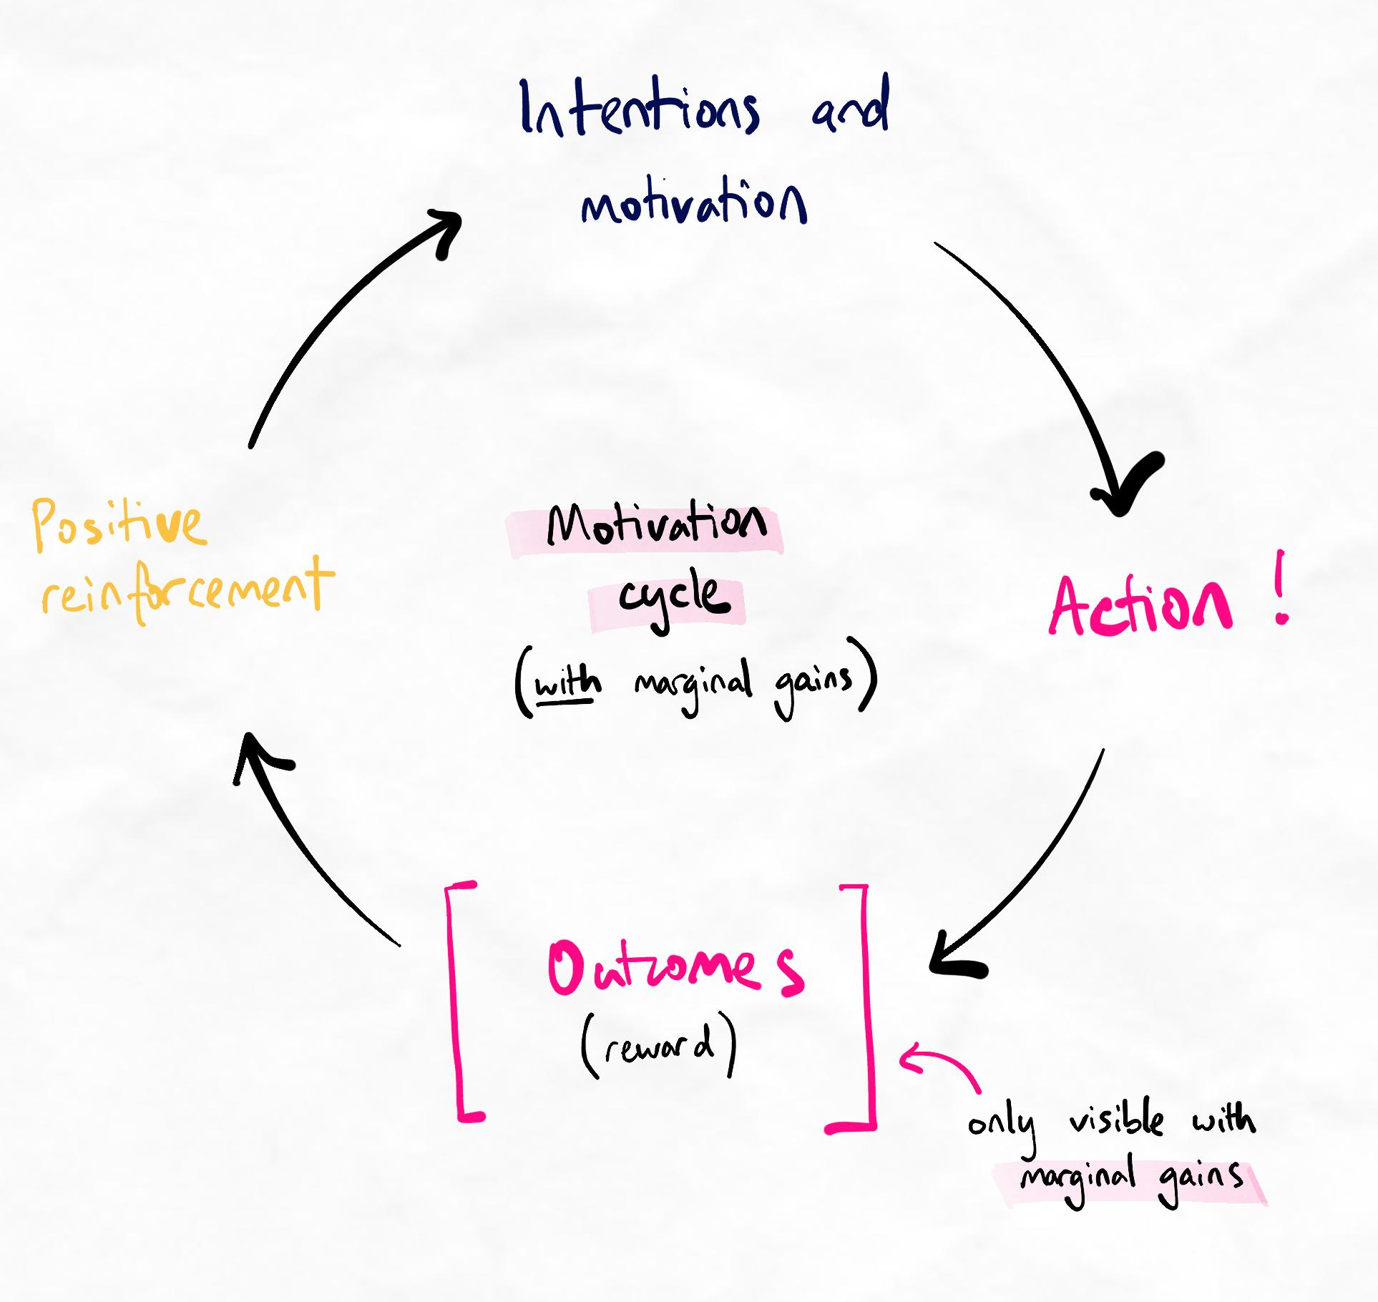
Without marginal gains, the outcomes become invisible, and we enter a demotivation spiral. Over time, this can lead to burn out as our efforts seem to be in vain.
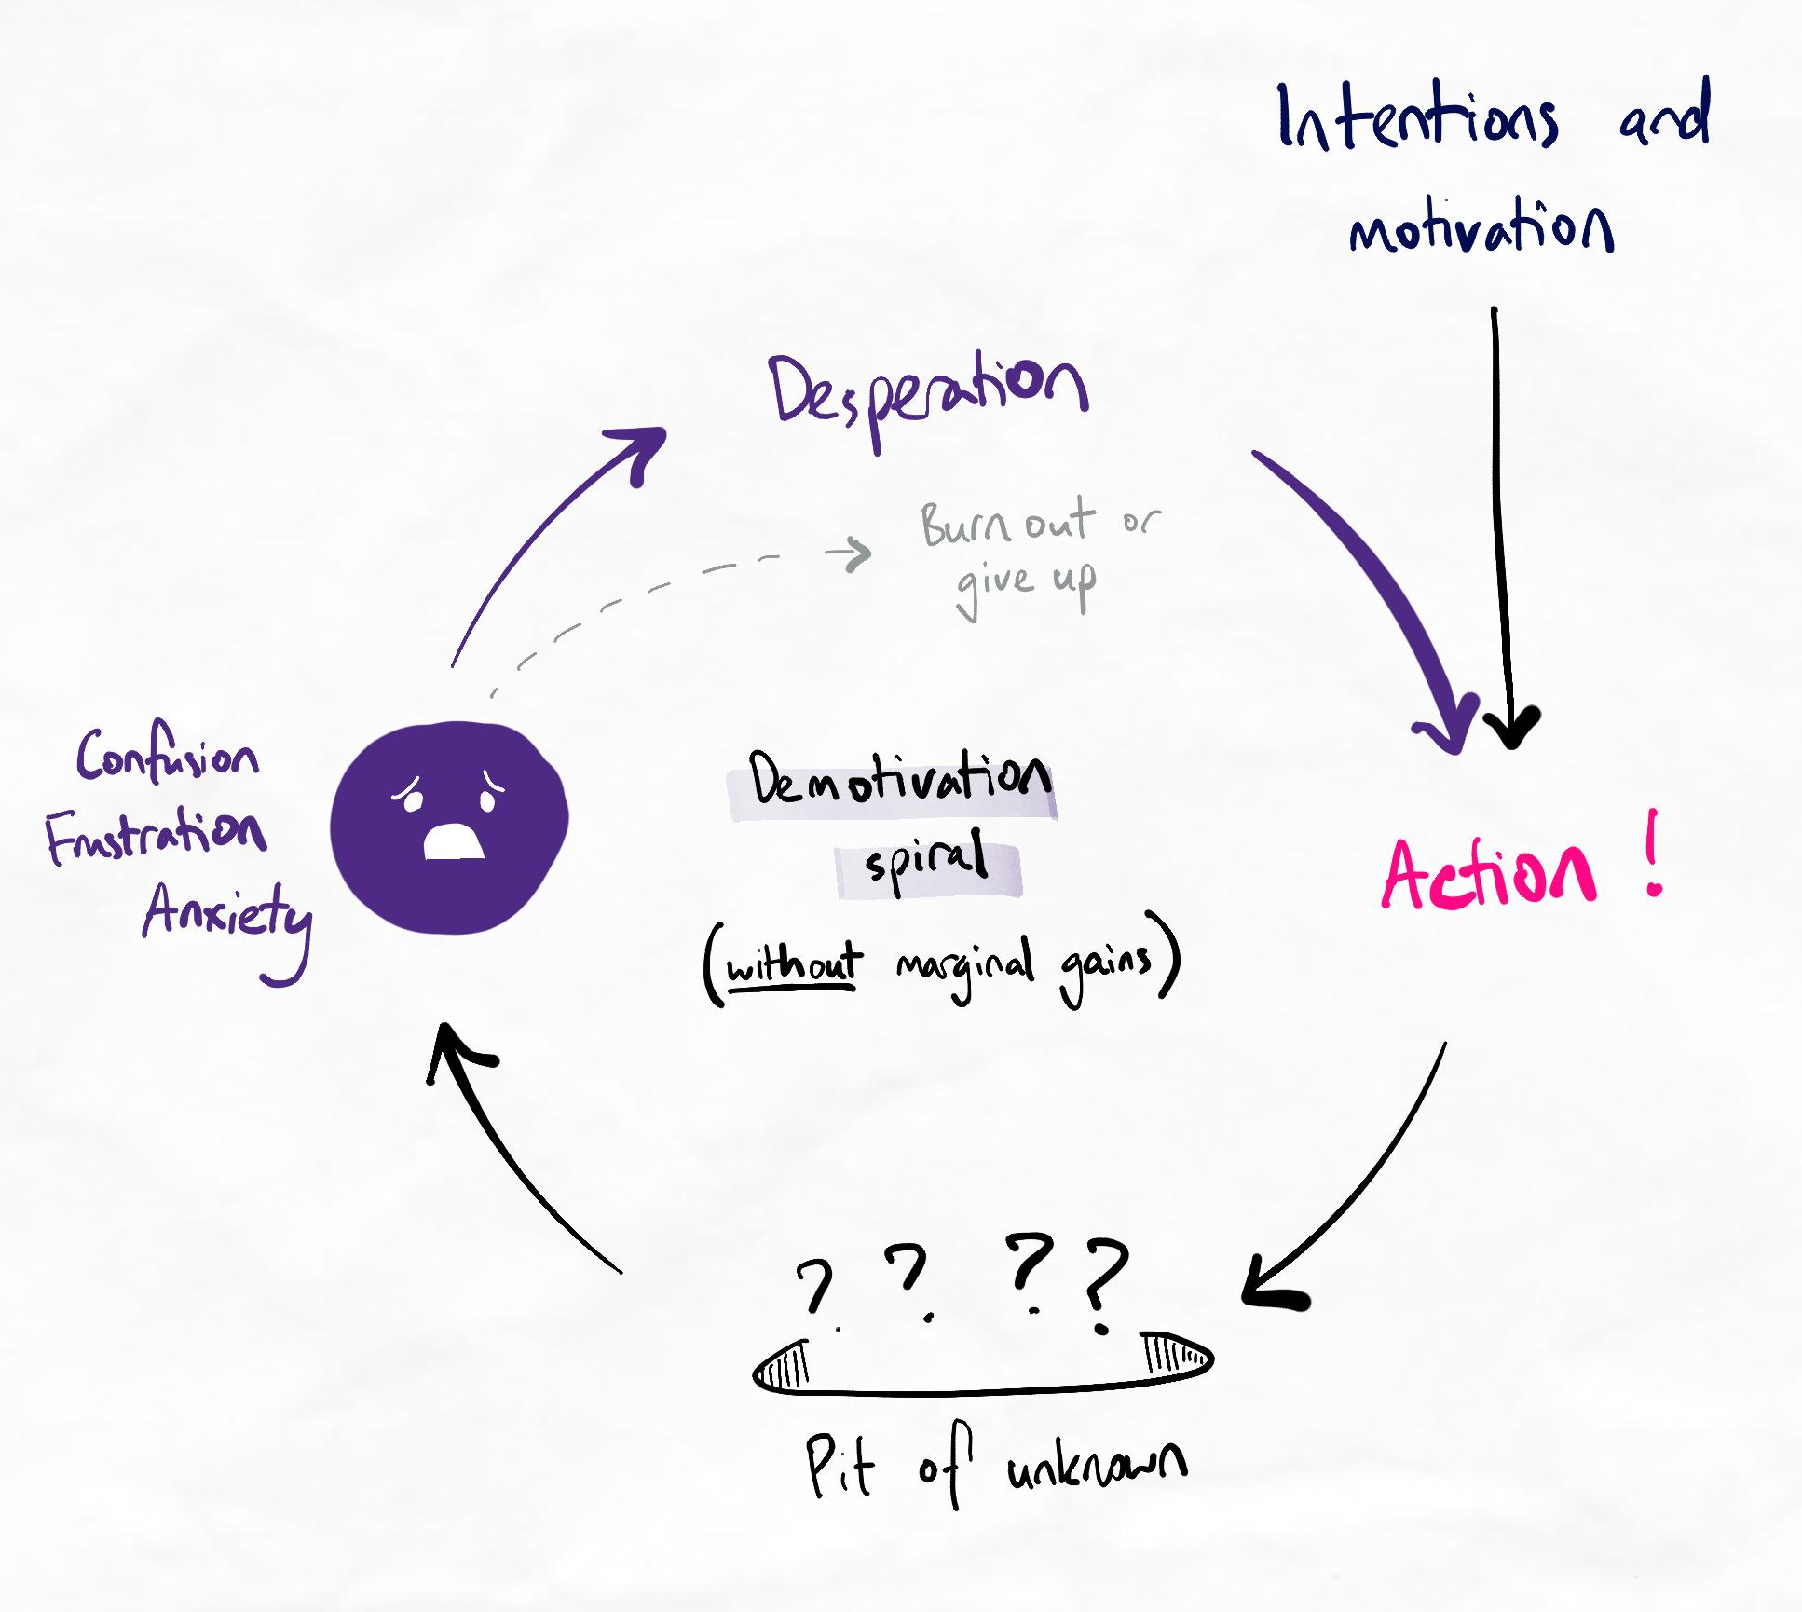
How do we track marginal gains?
Read our guidelines here on how you can track marginal gains. You will need this to complete the recommended tasks at the end of this lesson. You can access these guidelines again at any point from your Learning Support page.
Moving forward
In the later stages of the program, we will teach you additional methods that you can add to these steps to make them more targeted. For now, gain familiarity and experience with thinking about progress through the framework introduced in the article above.

  - Marginal gains for studying

In this video, deepen your understanding of marginal gains and see how we can pick compounding instead of additive gains to give us the greatest effect, using school or university subjects/papers as examples.
This sublesson is aimed at students. Although it may not be as directly relevant for professional learners you can still get some helpful ideas from this example!
Sneak peek
Interested in seeing what the full system you will develop throughout this program looks like? We've prepared a special sneak peek lesson for you here. This is entirely optional for now, and you will be asked to review this lesson at the end of Fundamentals 2 anyway.
Marginal gains
Taking the first steps
Viewing progress through marginal gains is about more than understanding the concept.
It needs to become a habit. Most people do not think about progress via marginal gains "naturally". We commonly see learners who use marginal gains perfectly when setting goals but forget about them when viewing their mistakes.
Their old thinking habits make them continue to think, "I'm not improving even though I'm trying so hard". Despite knowing that they should think about marginal gains, they fail to catch themselves when they do not.
Key principle
Habits operate so fast and subconsciously that we can be aware of how we must think and act but still struggle to stop ourselves from doing the same thing we are used to. Retraining this takes time, diligence, and self-awareness.
Therefore, it's vital that we try to retrain our habit of thinking about progress through the lens of marginal gains. Complete the following recommended tasks to help start this retraining process.
Recommended tasks
Add tasks to your focus list so you can practice the skills.
Dimensions
Fundamentals
Identify your marginal gains for learning efficiently
Follow the five steps outlined in our "Tracking marginal gains" guide here to identify your 1% gains for learning efficiency. Complete this task once you have compounded your 1% gains at least three times. This means you have:
  - Identified a marginal gain
  - Tried to reach it
  - Reflected on the experience
  - Identified the next marginal gain with our 5-step framework
  - Repeated this process twice
Remember that marginal gains in the early stages often involve identifying gaps in knowledge, learning more about what action to take, and building basic self-awareness.
Tip:
Check out what other learners think of as marginal gains in the #wins-and-gains channel on our Discord community. This is an excellent source of ideas. We encourage you to post your marginal gains on this channel, too!

